Substitutions
Team 1
1 |  | For
2 |  | For
3 |  | For
4 |  | For
5 |  | For

Team 2
1 |  | For
2 |  | For
3 |  | For
4 |  | For
5 |  | For

Blood Substitutes
Team 1
1 |  | For
2 |  | For
3 |  | For
4 |  | For
5 |  | For

Team 2
1 |  | For
2 |  | For
3 |  | For
4 |  | For
5 |  | For

REFEREE’S SIGNATURE

Umpires Supplied 1 2 3 4 tick appropriate

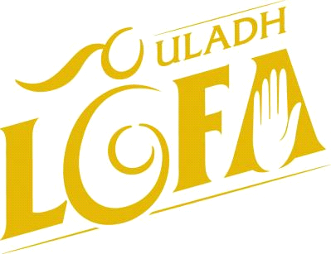

ULSTER SCHOOLS REFEREE’S REPORT FORM
Referees
Name

Return Ulster Ladies Fixtures Secretary & cc PPS Coordinator
E-mail fixtures.ulster@lgfa.ie & ppscoord.ulster@lgfa.ie
Address 8-10 Market Street, Armagh, BT61 7BX

Phone result on day of match:

You are hereby notified that you are appointed to referee the game between:

TEAM 1 (HOME) | TEAM 2 (AWAY)
Venue: | Date:
Time: | Comp:

Provincial Schools Co-Ordinator:
Hannah Caldwell
07831552851
ppscoord.ulster@lgfa.ie

Please supply at least 2 Neutral umpires
4 umpires required every game

Teams took the field at:
Team 1: | Team 2:

Game Commenced at: Game ended at:
Score:
Half Time | Team 1 | Goals | Points | Team 2 | Goals | Points
Full Time | Team 1 | Goals | Points | Team 2 | Goals | Points

Attire of players:
Were the players properly togged out in correctly numbered jerseys, and uniformity of shorts and socks. Yes/

Pitch Marking: Flags: Nets:

Umpires:

Linespersons:

Additional Information:

Name of player injured: Continue
Playing:
Player Injured | Type of Injury | yes | No

Players Yellow carded and Reason:

Rule: | Players Name: | Additional comments:

Players Red carded and Reason:

Rule: | Players Name: | Additional comments:

Officials Booked and Reason:
Rule: | Officials Name: | Additional comments:
Player’s who played exceptionally well. No more than two. U16 only
Please enter two names as this goes towards young player of year

1 2

